1. Use the tangent method to calculate the instantaneous velocity at:
   1. At Time = 3 seconds
   2. At Time = 6 seconds

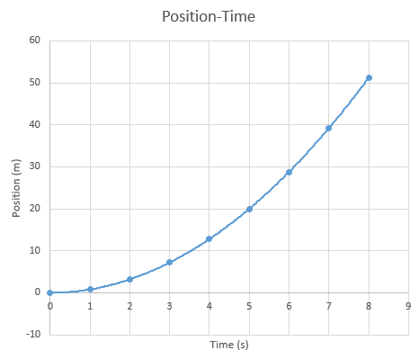

1. Use the tangent method to calculate the instantaneous velocity at:
   1. At Time = 3 seconds
   2. At Time = 6 seconds

